**Department of Computer Science and Engineering**

|  |  |
| --- | --- |
| **Course Code: CSE 110** | **Credits: 1.5** |
| **Course Name: Programming Language I** | **Semester: Sum’18** |

**Experiment/Lab 07  
This is Experiment seven**

1. **Topic Overview:**

This lab focuses java loops and its extended uses by using them in lab tasks. Moreover, students have to build and print certain types of shape which will enable them to visualize the working of loops.

1. **Lesson Fit:**

Basic knowledge about loops (loop structure) is required for this lab which actually discussed in previous labs and theory classes.

1. **Learning Outcome:**

After this lecture, the students will be able to:

* 1. Understanding the usages of loops
  2. Understanding the trend of increment and decrement.
  3. Able to apply this knowledge to solve further problems that will be encountered in upcoming labs

1. **Anticipated Challenges and Possible Solutions**
   1. Relating rows and columns with loop structure

**Solutions:**

* + 1. Explicitly describing this portion and giving examples to show students how to relate row and column count with loop’s increment and decrement.
    2. Using meaning full name (spaceCount, columnCount) will solve the problem
  1. Printing hollow shapes

**Solutions:**

* + 1. Using of if else condition will solve this problem

1. **Acceptance and Evaluation**

If a task is a continuing task and one couldn’t finish within time limit, then he will continue from there in the next Lab, and if it is a one Lab task then it will be given as a home work and in the next Lab you have to submit the code and have to face a short viva. A deduction of marks is applicable for late submission. The marks distribution is as follows:

1. **Activity Detail**
   1. **Hour: 1  
      Discussion:**first we will review the basic structure of loops and their syntax as well as show some example **Problem Task:**
      1. Problem 1-10(Page 1-2)
   2. **Hour: 2**

**Discussion:**

Understanding the procedure of printing “space” and building hollow shapes

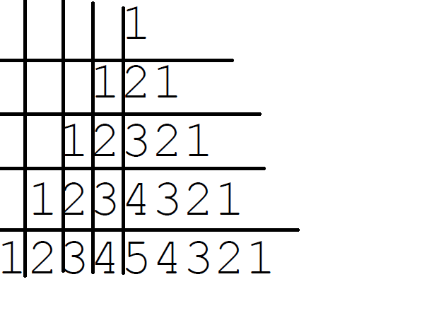

**Problem Task:**

* + 1. Problem 10 -17 (Page 3-6)
  1. **Hour: 3**

**Discussion:**

Continuation of the previous tasks

**Problem Task:**

* + 1. Problem 18-25

1. **Home tasks**
   1. Home Task 1 - 25

**Experiment/Lab 7 Activity List**

**Lab 7**

Rules:

∙ You are not allowed to use any **array** or **String**

∙ One only line where the word “**String**” may appear is in public static void main(**String** [] args) {

∙ The word “**char**” must not be anywhere in your solution

**Overall hint:** Imagine all outputs as a matrix of space and star. Then count spaces and

stars to find out the trend of increment or decrement of number of stars/spaces. Utilize

several **IF statement** to control when ‘**star’** will be printed, when ‘**space’** will be printed

and when ‘**enter’** will be printed.

PROBLEM 1) Number Line

Sample input:

6

Sample output

123456

PROBLEM 2) Star Line

Print as many stars as given in input

Sample input:

6

Sample output

******

PROBLEM 3) Rectangle

Sample input:

4

6

Sample output

******

******

******

******

Hint: 4 and 6 means 4 lines of stars having 6 stars in each line.

PROBLEM 4) Rectangle

Sample input:

4

6

Sample output

123456

123456

123456

123456

Hint: 4 and 6 means 4 lines of numbers having 1..6 in each line.

PROBLEM 5) Triangle - Left Justified

Draw right angled triangle of given height

Sample input:

4

Sample output

*

**

***

****

**Hint:** One loop for lines, another loop for printing i number of starts when it is line i.

PROBLEM 6) Triangle - Left Justified

Draw right angled triangle of given height

Sample input:

4

Sample output

1

12

123

1234

PROBLEM 7) Triangle - Right Justified

Draw right angled triangle of given height

Sample input:

4

Sample output

*

**

***

****

Hint: Count and print appropriate number of spaces in front of stars. Notice that there

is one less space and one more star in each line.

PROBLEM 8) Triangle - Right Justified

Draw right angled triangle of given height

Sample input:

4

Sample output

1

12

123

1234

PROBLEM 9) Triangle - Isosceles

Draw triangle of given height

Sample input 1:

3

Sample output 1:

*

***

*****

Sample input 2:

4

Sample output 2:

*

***

*****

*******

PROBLEM 10) Triangle - Isosceles

Draw triangle of given height

Sample input 1:

3

Sample output 1:

1

123

12345

Sample input 2:

4

Sample output 2:

1

123

12345

1234567

PROBLEM 11) Triangle - Right Justified

Draw right angled triangle of given height

Sample input

Sample output

4

34

234

1234

PROBLEM 12) Rhombus

Just draw the image of the above triangle once. And then, the opposite, once.

Sample input:

3

Sample output

*

***

*****

***

*

PROBLEM 13) Rhombus

Just draw the image of the above triangle once. And then, the opposite, once.

Sample input:

3

Sample output

1

123

12345

123

1

PROBLEM 14) Hollow Rectangle

Display a rectangle of given length and width.

Sample input:

4

5

Sample output

*****

* *

* *

*****

Hint 1: Print the character space (‘ ‘) in the middle.

Hint 2: You can re-use your solution to PROBLEM 2 and use if condition to selectively print first and last star of

each line and all stars of first and last line.

PROBLEM 15) Hollow Rectangle

Display a rectangle of given length and width.

Sample input:

4

5

Sample output

12345

1 5

1 5

12345

PROBLEM 16) Hollow Triangle - Left Justified

Draw right angled triangle of given height

Sample input:

5

Sample output

*

**

* *

* *

*****

PROBLEM 17) Hollow Triangle - Left Justified

Draw right angled triangle of given height

Sample input:

5

Sample output

1

12

1 3

1 4

12345

PROBLEM 18) Hollow Triangle

Draw right angled triangle of given height

Sample input:

5

Sample output

*

**

* *

* *

*****

PROBLEM 19) Hollow Triangle - Right Justified

Draw right angled triangle of given height

Sample input:

5

Sample output

5

45

3 5

2 5

12345

PROBLEM 20) Hollow Triangle

Draw triangle of given height

Sample input 1:

3

Sample output 1:

*

* *

*****

Sample input 2:

4

Sample output 2:

*

* *

* *

*******

PROBLEM 21) Hollow Triangle – Isosceles

Draw triangle of given height

Sample input 1:

3

Sample output 1:

1

1 3

12345

Sample input 2:

4

Sample output 2:

1

1 3

1 5

1234567

PROBLEM 22) Hollow Rhombus

Just draw the image of the above triangle once. And then, the opposite, once.

Sample input:

3

Sample output

*

* *

* *

* *

*

PROBLEM 23) Hollow Rhombus

Just draw the image of the above triangle once. And then, the opposite, once.

Sample input:

3

Sample output

1

1 3

1 5

1 3

1

PROBLEM 24) Palindrome

Sample input:

5

Sample output

123454321

PROBLEM 25) Palindromic Triangle

Sample input:

5

Sample output

1

121

12321

1234321

123454321